# Day 3 - Create Users
1.**Pick 3+ realistic people across different departments**
Users: Thabo Nkosi, Lindiwe Dube, Sipho Mahlangu

2. **Add `karabonode.co.za` as an alternative UPN suffix first.**
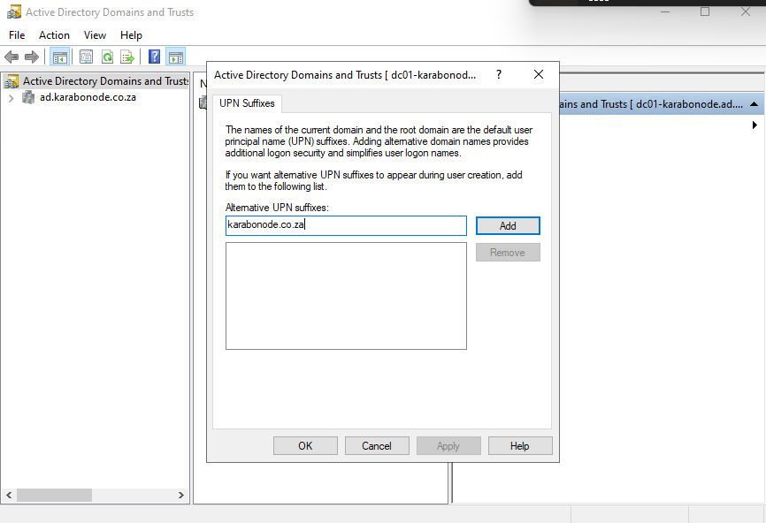
# confirm karabonode.co.za is listed
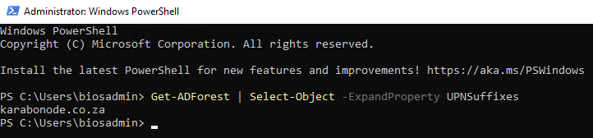

3. **Create each user with `New-ADUser`**

-converting it into a SecureString that PowerShell can safely pass to the Active Directory cmdlet.
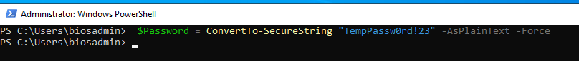

Register all users onto the domain
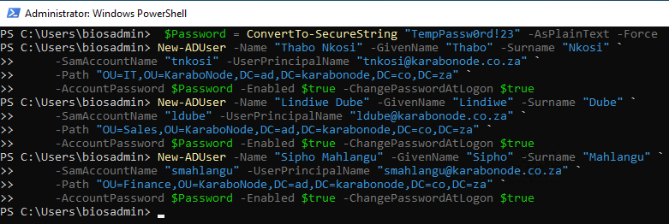

*Confirm the UPN is in proper email format** for every account:
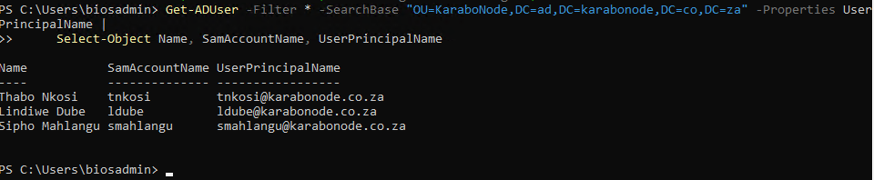

SamAccountName VS UserPrincipal

SamAccountName is the traditional logon name used to login into windows, it the legacy identifier used by Active Directory and older Windows.

UserPrincipalName is the morden AD logon Name, it looks like an email address, but it is primarily an authentication/logon identifier. It does not have to be the user’s email address. UPNs are especially useful in morden Microsoft environments as Microsft Entra ID/ MS 365

What is a logon identifier
A piece of information a system uses to identify which user is trying to sign in

